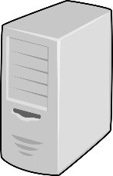**Diagrama de Red - CALIDAD**

**I**

**N**

**S**

**T**

**I**

**T**

**U**

**C**

**I**

**Ó**

**N**

**AS400**

172.31.4.64

**Active Directory**

172.31.42.18

**HSM Thales**

172.27.0.30

**Máquina Virtual**

172.31.55.31

**Máquina Virtual**

172.31.55.30

**Server BBDD**

172.31.4.58

**Server Bus**

172.31.4.59

**WebPCI**

172.31.4.23